SQLite3 Notes

Install SQLite3 on Windows:
>Download the sqlite-dll-win-x64 zip and the sqlite-tools-win-x64 zip.
>Unzip them and copy the sqlite3.exe, sqlite3.def and sqlite3.dll to a new folder created in C: drive named sqlite.
>Finally, copy the path of the new folder and add it to the environment variables in windows. Select the Path variable, click edit and then click new to add the new path in there for sqlite.
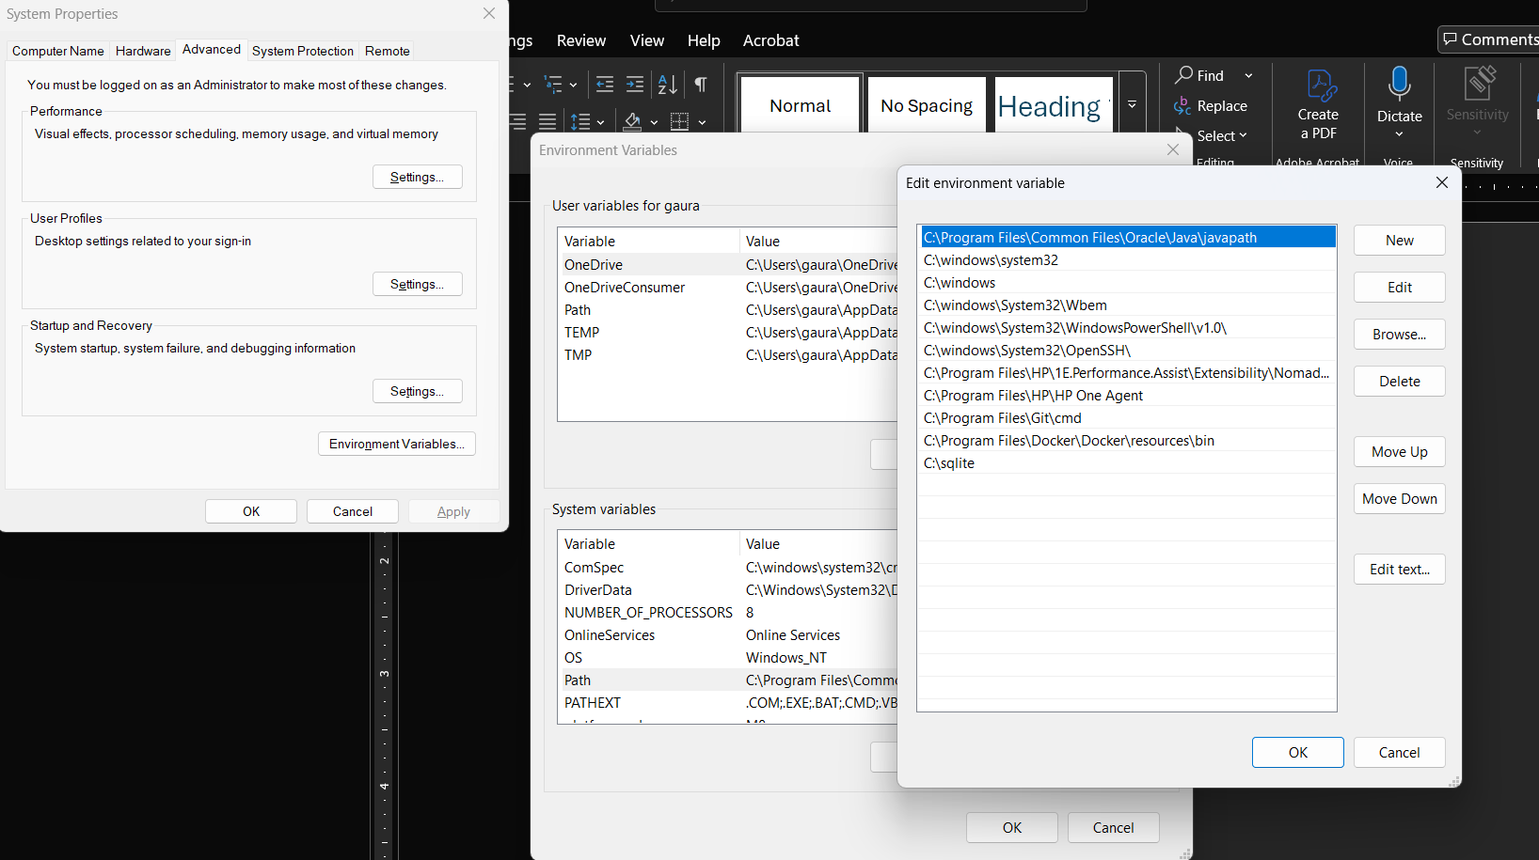

Creating tables in sqlite3:
CREATE TABLE flights (id INTEGER PRIMARY KEY AUTOINCREMENT, origin TEXT NOT NULL, destination TEXT NOT NULL, duration INTEGER NOT NULL);

Inserting data in sqlite3:
INSERT INTO flights (origin, destination, duration) VALUES ('Shanghai', 'Paris', 760);

Create the rows and columns nicer in sqlite3:
>We can do .mode columns and .headers yes to make it nicer.
sqlite> select * from flights;
1|New York|London|415
2|Shanghai|Paris|760
3|Istanbul|Tokyo|700
4|New York|Paris|435
5|Moscow|Paris|245
6|Lima|New York|455
sqlite>
sqlite>
sqlite> .mode columns
sqlite> .headers yes
sqlite>
sqlite> select * from flights;
id origin destination duration
-- -------- ----------- --------
1 New York London 415
2 Shanghai Paris 760
3 Istanbul Tokyo 700
4 New York Paris 435
5 Moscow Paris 245
6 Lima New York 455

Exit out of sqlite3 console:
type .quit or .exit and press enter.

Types of SQL queries we can run:

Using = sign for checking something:
sqlite> SELECT * FROM flights WHERE origin = 'New York';
id origin destination duration
-- -------- ----------- --------
1 New York London 415
4 New York Paris 435

Using >, < then signs:
sqlite> SELECT * FROM flights WHERE duration > 500;
id origin destination duration
-- -------- ----------- --------
2 Shanghai Paris 760
3 Istanbul Tokyo 700

Using AND
sqlite> SELECT * FROM flights WHERE duration > 500 AND destination = 'Paris';
id origin destination duration
-- -------- ----------- --------
2 Shanghai Paris 760

Get values based on sequence of values using IN:
sqlite> SELECT * FROM flights WHERE origin IN ('New York', 'Lima');
id origin destination duration
-- -------- ----------- --------
1 New York London 415
4 New York Paris 435
6 Lima New York 455

Using LIKE:
sqlite> select * from flights where origin LIKE '%a%';
id origin destination duration
-- -------- ----------- --------
2 Shanghai Paris 760
3 Istanbul Tokyo 700
6 Lima New York 455

Using Update:
sqlite> update flights set duration = 430 where origin = 'New York' and destination = 'London';

Using DELTE:
sqlite> select * from flights;
id origin destination duration
-- -------- ----------- --------
1 New York London 430
2 Shanghai Paris 760
3 Istanbul Tokyo 700
4 New York Paris 435
5 Moscow Paris 245
6 Lima New York 455

sqlite> delete from flights where destination = 'Tokyo';
sqlite> select * from flights;
id origin destination duration
-- -------- ----------- --------
1 New York London 430
2 Shanghai Paris 760
4 New York Paris 435
5 Moscow Paris 245
6 Lima New York 455

